|  |
| --- |
| BLUEsat UNSW Student Satellite Project  Document BLUE.2011.9001 |
| V2 Power Subsystem |
| Progress Report Aug 2012 |
| **Authors and Contributors:**  Cameron Brown  Mitch Wenke  **Date:** |
| August 11, 2012 |

# Introduction

The BLUEsat V2 Power Subsystem is the new structure for power control and distribution in the satellite. It increases reliability and redundancy, while reducing complexity and cost, as well as standardising a single architecture across all rails and rail types. We have a prototype PWA constructed, and initial testing has been very promising.

# Table of Contents

1 Introduction 1

2 Table of Contents 1

3 New Specifications 2

4 Current Development Board 5

5 Future Work 7

# New Specifications

The new Power system features a standardised channel design, such that a single design block can be used for all power rails, with just a change in resistor values. The design uses the "Simple Switcher" system from National Semiconductor, along with redundancy controllers from Linear Technology.

*Figure 1 - Design Block Layout*

Figure 1 shows the contents of a single design block, that can be configured for any of the needed output voltages. The entire block is controlled and monitored by a serial I2C interface, which includes the ability to control the two regulators, the redundancy controller and the high side load switch, and is able to set the output voltage to any of 16 steps. The bus is bidirectional, and is able to monitor the Power Good and Fault flags generated by the redundancy controller.

The redundancy controller features full short circuit and over current protection, with a hiccup and retry processes, fault flags generated by these modes are able to be monitored by the serial interface. The over current protection is settable for each load, to prevent damage, or sense a short circuit failure.

*Figure 2 - Distribution System*

Figure 2 shows the distribution system and loads and shows the structure of the new power subsystem. All the regulators are able to be shut down by the serial interface, except the 3.3V regulators which power the Critical Systems Computer. All loads except the CSC are high-side switchable.

The regulators have low voltage shutdowns which turn off all rails except 3.3V when the battery reaches a predefined low level. In an emergency situation, the regulators could be forced on, but this would be outside of the normal enable/disable operation of the serial bus.

# Current Development Board

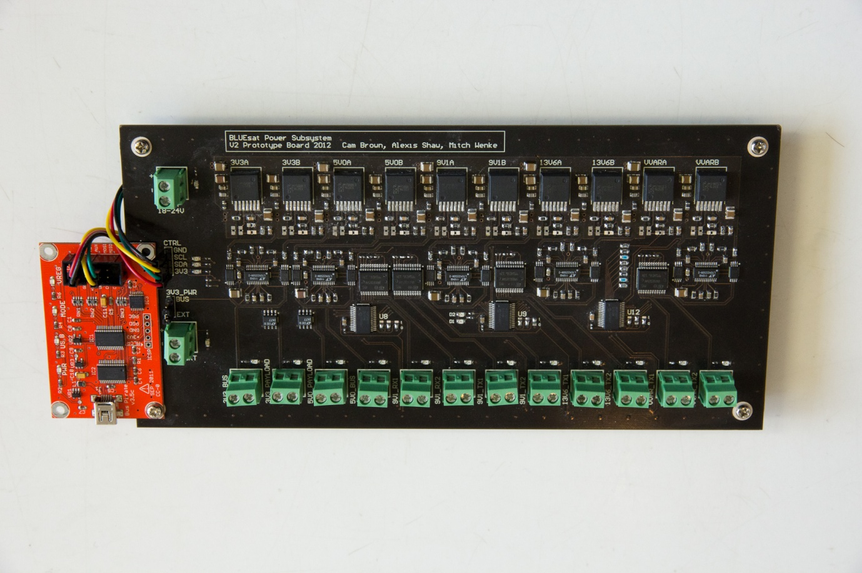

*Figure 3 - Picture of power system test PWA*

Figure 3 shows the current test PWA for the new power subsystem. The board has the power traces broken out to screw terminals along the bottom, and I­­2C headers along the left. These are just for the sake of prototyping, as the routing of the actual circuitry is already suitable for final implemenation. The red board in the picture is a USB -> I2C converter for use with our testing software, shown in Figure 4.

The board has been extensively tested, and is performing as designed.

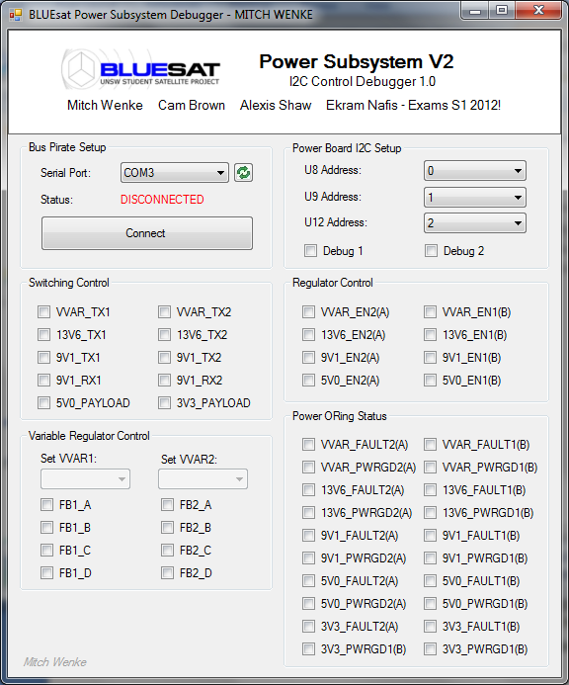

*Figure 4 - PC control test software*

# Future Work

This future of the power subsystem is to be directly dropped into the tray 2 PWB. The routing already facilitates this, and will require minimal modification due to the successful testing.